Bear Elective Adventure: Make It Move

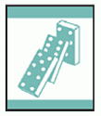
- Create an “exploding” craft stick reaction.
- Make two simple pulleys, and use them to move objects.
- Make a lever by creating a seesaw using a spool and a wooden paint stirrer. Explore the way it balances by placing different objects on each end.
- Do the following:
  - Draw a Rube Goldberg–type machine. Include at least six steps to complete your action.
  - Construct a Rube Goldberg–type machine to complete a task assigned by your den leader. Use at least two simple machines and include at least four steps.
Workbook for use with these requirements: PDF Format DOCX Format

Clothespin Button Racer

http://almostunschoolers.blogspot.com/2010/12/clothespin-button-racer.html

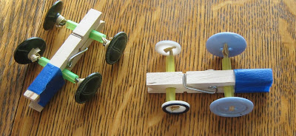
For a easy boredom buster, gather together:
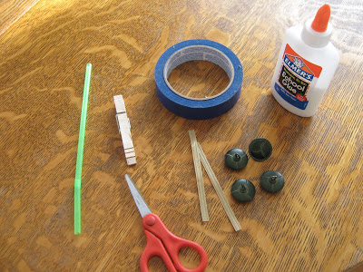

- 1 clothespin (per car)
- 4 buttons, of the same size
- 1 drinking straw
- 2 bread ties
- colored tape
- school glue (optional).

Cut two, one inch, pieces from the straw.
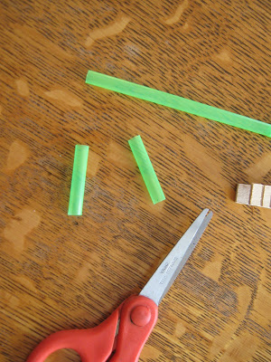
Thread the bread ties through the straws, and secure a button on each side, either looping the bread tie through the back hook, or the holes, depending on the type of buttons you have.
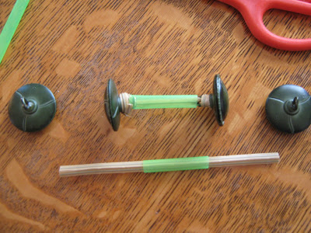
Clip one of the straw axles in the front of the clothespin. You can glue it in place, but that isn't necessary.
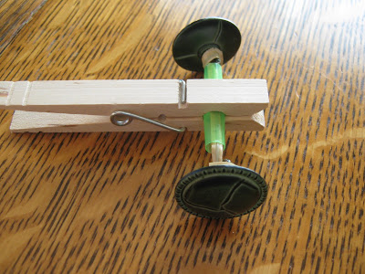
Slide the other straw axle into the back of the clothespin, up against the spring.
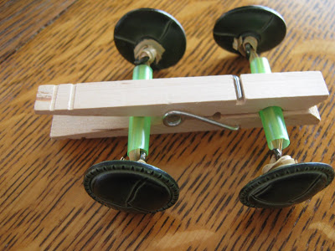
Secure it in place with a piece of tape, as shown.
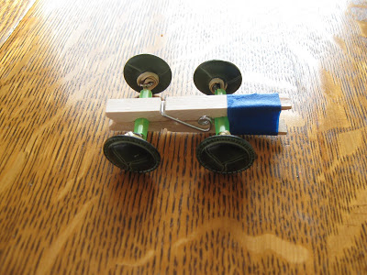
Make more than one...
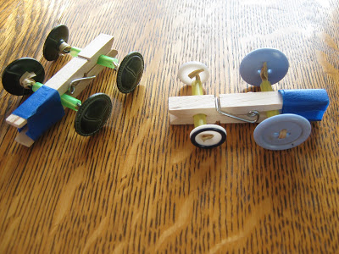
...and let the racing begin.
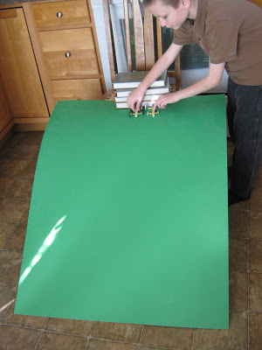
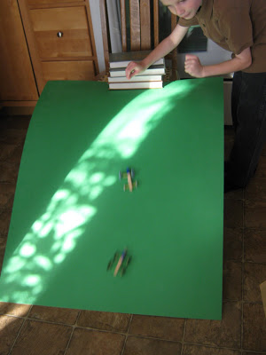
If you don't have a large piece of poster board, you can make a pretty good racing ramp out of an empty cereal box, too.
I found the idea for this toy, in Mary Wallace's excellent, for-kids, toy making book, I Can Make Toys. It's one of those books, where almost every idea looks like fun, and can actually be done by children, on their own.
It's great to be a homeschooler.

Rube Goldberg Machines for Kids + YouTube Video!
http://onetimethrough.com/rube-goldberg-machines-for-kids-youtube-video/

Today – we’re sharing with you our creation – the “Auto Helicopter Machine!” – along with all our trials and tribulations with the hope that you might try out this amazingly educational and FUN activity with your kids too!
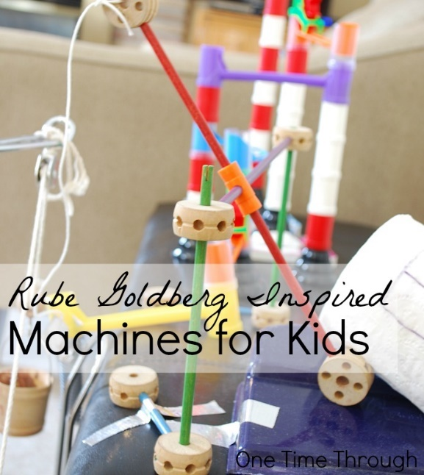
So what is a Rube Goldberg machine anyway? According to the Official Rube Goldberg Machine Contest website it is a “comically involved, complicated invention, laboriously contrived to perform a simple operation.”
It sounds a little daunting at first, I know…but realistically, you can make a machine as complicated as you want (or not) and the best part is – all you need are things from around the house (as you will see in our video below!)
Before I show you our video, I want to mention again that the inspiration for our project came from two posts from the Brain Power Boy blog. Between these 2 posts, you will find everything you need to get started making a Rube Goldberg machine with your child/children – just like we did.
In the post Play and Learn with Rube Goldberg Machines, you will find games, apps, recommended books and toys as well as some links to resources that will help you get started.
In the post Rube Goldberg Videos, you will find 8 videos that will get your child super-inspired to make a machine of their own. Onetime had a blast watching these (as did I!) and wanted to make one of his own right away!
Okay – without further adieu, here is One Time Through’s second official video (now available on our new You Tube channel! Yay!) – or right here for your enjoyment.
Hope you enjoyed watching our fun!
We may have gone a little overboard – after all, our machine filled our entire living room – and it took 2 days of tinkering to complete – but Onetime was right there highly interested the entire time – so why not go with it!?
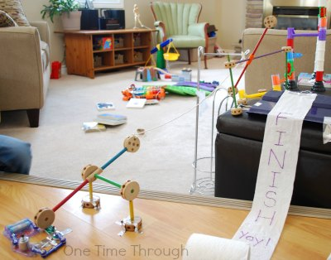And by the way, the perfectionist in me has to just say that every part of our machine did actually work – just not all at the same time – and with a trigger happy kid who kept starting the machine before I got the camera ready or a last part in place – it was never going to get caught on video – and I accepted that! LOL.
Onetime learned a whole lot from setting this whole thing up with me though.
Although I came up with the ideas, he helped me collect the items from around the house, helped build the Tinkertoy parts, the marble run contraption, and the Elenco Electronic Snap Circuits, Jr. Kit component at the end that when disconnected – let the helicopter fly.
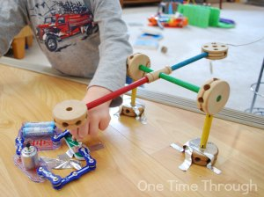
He also got lots of hands-on time investigating our bucket pulley system (which unfortunately got triggered early in our video and so didn’t get caught on tape) – and the levers that when triggered let the toilet paper “flag” roll out – and which tapped the final circuit off.
Our machine probably would not have been quite as fun without the Tinkertoy Super Building Set, marble run (we used the Migoga brand) and Elenco Electronic Snap Circuits, Jr. Kit toy elements, and I highly recommend all 3 (we use them all the time!).

Sum-Up: How to Do a Rube Goldberg Project and Not Lose Your Mind

https://gwynridenhour.wordpress.com/2012/03/14/sum-up-how-to-do-a-rube-goldberg-project-and-not-lose-your-mind/

How To Do A Rube Goldberg
1. Begin with youtube. Just spend a morning searching for Rube Goldberg videos – there are hundreds! And so amazing. Here are a couple of my favorites:
2. Don’t forget to look at the original drawings too! Try Rube Goldberg: Inventions by Maynard Frank Wolfe.
3. Discuss with your students that this is about process as much as the end result. The magic of the Rube is the myriad opportunities it provides for problem solving! Be sure to show them the Mythbusters Christmas special, which shows not only their Rube Goldberg project, but provides a delightful insight to how many times things go wrong in a project like this, even for professionals.
4. Instruct students to decide on themes and an end action. Will the machine tell a story? What is its ultimate goal? Each portion of the machine has to receive an action that converts its potential energy to kinetic energy. It also has to cause the next action to happen. But don’t forget humor – this should be fun! My kids incorporated several of their favorite story lines into their project, including Harry Potter, Munchkin, and Eva’s beloved stuffed animal Kinzy.
5. Consider offering certain parameters. If you’re wanting to study simple machines as a part of this project (which I did), require the students to incorporate them. They’ll do this anyway, because Rube Goldbergs are all about simple machines! But by requiring certain machines, it helps students identify the components they’re using and think about them scientifically. Parameters also help get the kids started. The only machine I required for the kids was a pulley. I also required that the final machine be comprised of at least five components. But the rest was up to them.
6. Have your students draw out ideas for their machines. Or not. Follow your kids’ leads. If they’re list-makers, let them make lists. If they feel the need instead to just get started, then let them. Again, this is all about process.
7. Be prepared to ditch large amounts of work if necessary. If something’s not working, then change it to make the project successful. We had to change everything, including our timeline, materials, and even who would be working on it.
8. Ask discussion-oriented questions when things go wrong and be sure to have kids identify several things. Ask 1) what went wrong, 2) what made it go wrong, and 3) what are the possible solutions. Be sure to have them identify many possible solutions before choosing one. For example, when our broomstick fell too quickly on our falling pendulum, the kids identified all the things that could slow it down. They could increase friction, decrease the broomstick’s weight, or decrease the incline of the pendulum track. We discussed the pros and cons of each avenue before the kids made their choice.
9. Do not be in a hurry. Rube Goldbergs can take a lot of time, depending on how much the kids bring to it. Don’t rush the process.
10. Video, share, and celebrate your successes! Take advantage of youtube, facebook, email, your school website, friends, and family. If you’re into it, do a blooper reel too.
11. And lastly, I offer a prequel suggestion. Rube Goldberg machines are a great way to teach physical science. We did a semester of physics and simple machines before we started the Rube. I used Lego WeDo Education (which was a great concept, but the software was constantly crashing), Forces and Motion Science Fair Projects by Robert Gardner, Zombies and Forces and Motion by Mark Weakland, and a cute albeit dated series of clips I found on youtube by Eureka. You’ll find them by going to youtube and typing “simple machines Eureka.” There are a lot of other great instructional simple machines videos too, so have fun browsing around.
And now for the closeup tour. First, the video once again:
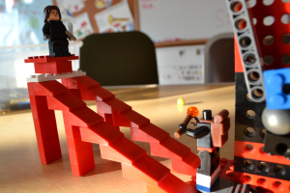
This is component number one, a simple ramp. The kids love the game Munchkin, and in that game there is a card called “Kill the Hireling.”
They think that’s hilarious and chose to use it for the first piece. The hireling (the lego figure at the bottom) ended up having to go without a head, because its head kept getting in the way. But we thought that was funny too.
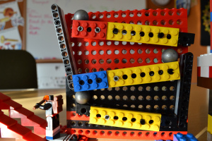
This next component is one that we saw in a lot of other Rube Goldberg machines. The goal is to transfer movement from low to high using ramps, balls, and levers. Each ramp allows the ball to roll down and into a lever; the lever transfers the motion upwards to the next ramp.
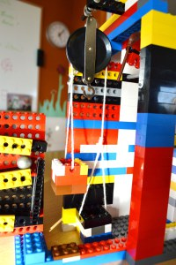
The top ball falls into a bucket that’s attached to a pulley. The pulley system has a counterweight which is offset by the ball’s action.
…
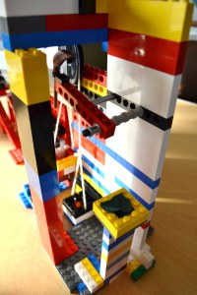
When the pulley system is activated, it pulls a string (I did help with the tying of the string) that’s attached to a stick that props up a flying broomstick (a nod to Harry Potter). Once that stick is pulled away, the broomstick swings on a pendulum.
At the end of the broomstick’s arc is Kinzy’s bowl of eucalyptus. This bowl gets knocked off its pedestal and onto Kinzy’s table. Lunch is served!
